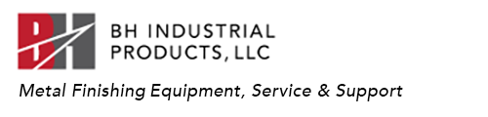

Parts Finishing Request Form:
The Parts testing lab offers sample processing for equipment, media and compound selection.
Any work done in the lab is warranted to perform.
Details of the process with instructions are given with the purchase of equipment and/or consumables.
We offer on-site consultation for machinery and parts process evaluation.

Company ___________________________________

Contact/Title__________________________________

Email___________________________________________

Phone_______________________________________

Street___________________________________________

City, State, Zip_____________________________________

Website__________________________________________________

1. Type of Metal. What is the part manufactured for?___________________________
_____________________________________________________________________

2. Method of manufacturing_________________________________________________________
_____________________________________________________________________
3. Production Numbers Daily, Weekly_______________________________________________________________
_____________________________________________________________________
4. Parts Dimensions_____________________________________________________
_____________________________________________________________________
5. Finishing Requirements._______________________________________________
_____________________________________________________________________
_____________________________________________________________________
6. What’s your existing equipment, consumables used, Timecycles?___________________________________________________________
__________________________________________________________________________________________________________________________________________
7. Post operation, i.e. Anodizing, Powder Coating, Assembly, Tooling._________________________________________________________________
_____________________________________________________________________
8. What equipment and or consumables are you inquiring about?_________________
_____________________________________________________________________
_____________________________________________________________________
9. What type of waste water filtration system do you use at your facility_______________________________________________________________
____________________________________________________________________

For testing purposes send unfinished parts to the address below.
Depending on the size of the parts 5 to 15 are adequate .
We request you send samples of your existing finished piece.
If available a sample part showing the new results required.
Pictures of the parts with details also helps.
Send parts and email the lab process request to:
BH Industrial Products LLC.
Research & Development.
Attn: Lab Test Services
1905 Wilcox Ave. Suite 766
Los Angeles California 90068
brian@metalfinish.co
818.602.1414

Additional Comments:_________________________________________
___________________________________________________________________________
___________________________________________________________________________
___________________________________________________________________________
___________________________________________________________________________
Regards,
Brian Hall

